1. Data Flow Diagram (DFD)

Level 0 — Context Diagram
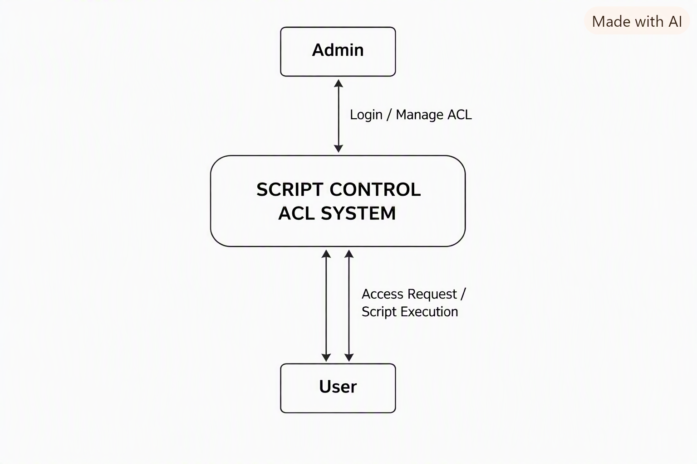
Level 1 — DFD

1. Data Flow Diagram (DFD)

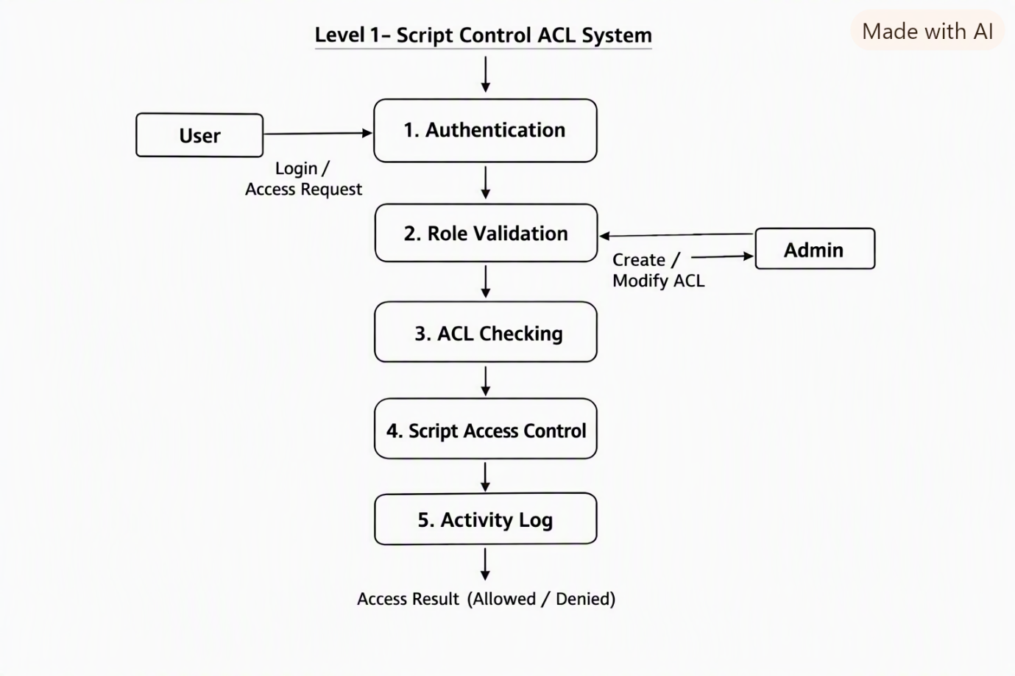

Main Data Stores

- User & Role Data

- ACL Rules

- Script Details

- Activity / Access Logs

---

2. User Stories

User Story 1 — Login

As a user, I want to log in securely so that only authorized users can access the system.

User Story 2 — Role-based Access

As an administrator, I want to assign roles to users so that users can access only the functions permitted to them.

User Story 3 — Create ACL

As an administrator, I want to create ACL rules so that I can control access to scripts.

User Story 4 — Read Permission

As an authorized user, I want read permission for permitted scripts so that I can view script details.

User Story 5 — Write Permission

As an administrator, I want to grant write permission to selected users so that they can modify authorized scripts.

User Story 6 — Execute Permission

As an administrator, I want to control script execution permission so that only authorized users can execute scripts.

User Story 7 — Unauthorized Access

As a system, I want to deny unauthorized script access so that scripts remain protected.

User Story 8 — Activity Log

As an administrator, I want to view activity logs so that I can monitor script access and changes.

User Story 9 — Manage Users

As an administrator, I want to manage users and their roles so that access permissions remain up to date.

User Story 10 — Permission Request

As a user, I want to request access to a restricted script so that an administrator can review my request.

Requirement Analysis-la heading order:**

3. Requirement Analysis
→ 3.1 Functional Requirements
→ 3.2 Non-Functional Requirements
→ 3.3 Data Flow Diagrams (DFD)
→ 3.4 User Stories

